|  |  |  |  |
| --- | --- | --- | --- |
| **Test units #** | **Test Case Description** | **Test Data** | **Expected result** |
| 1 | Check response when user attempts to resets | Click on reset button | Game has successfully reset |
| 2 | Checks user input under username, password, credit card and email | The user inputs are left blank or are not of valid length and characters | Alert box appears with appropriate warning. |
| 3 | Check response when valid email and password are entered | Email: [ABSI@email.com](mailto:ABSI@email.com)  Password: 56429A | Login is successful |
| 4 | Check to see if same puzzles will show upon completion of first one | Solve the puzzle successfully | Different puzzle will show up for different difficulty |
| 5 | Check to see if a timer would reset if a reset button was clicked | Reset button in clicked | Empty puzzle is displayed |

The snippets of each code unit is added with descriptions of the functionality. As well as the

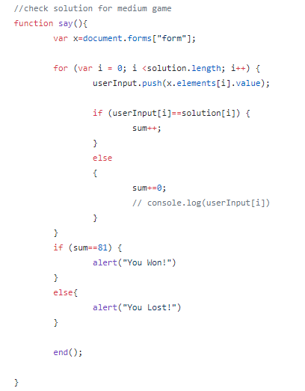  
  
  
  
  
  
  
  
  
  
  
  
Figure 1- This javascript function checks to see if the solution matches the sudoku puzzle for the medium difficulty level. The function is repeated for all difficulty levels, however the id called is different every time. As well as, the solution array the user input array is compared to is different for each level. The output is an alert saying “you won” if the user wins, and an alert saying “you lost” if the user loses. This was tested, and it works successfully in the program.

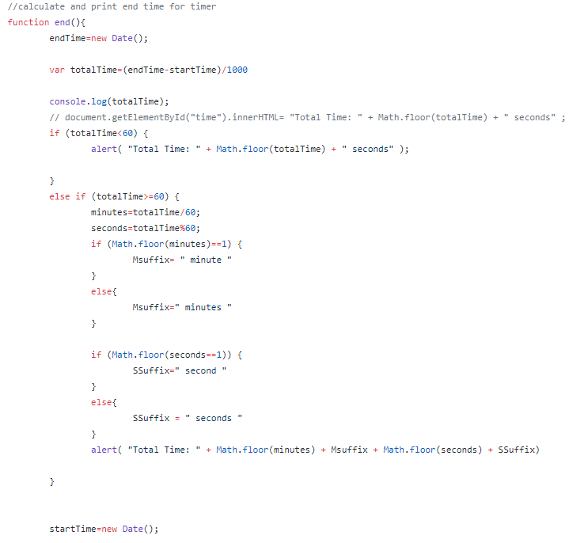

Figure 2- The function is added to for the time to show in the alert box when the user clicks submit. The time is converted to minutes  if the user takes more than 59 seconds. This implementation is achieved the

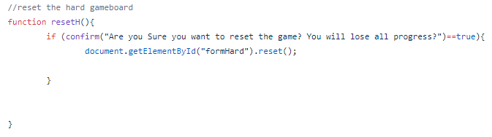

Figure 3- This function clears the sudoku puzzle according to the difficulty level. Which is implemented using a confirmation. The output is an alert asking the user if they want to reset the game board, if the user selects yes, the game will be reset, if the user selects no, the game will not be reset. This was tested and both outputs function successfully

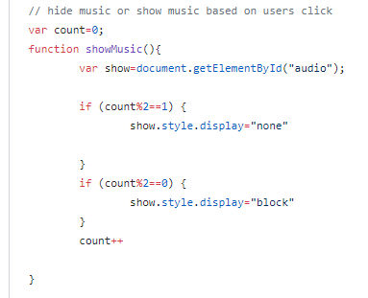

Figure 4- The showMusic() function allows the user to hide or display their youtube music while still listening to it. A variable is initialised before the function, the first click allows the youtube block to display the music and the music videos are hidden when the user clicks the button again. The output should be the music showing every second click. This was tested, and it works successfully.

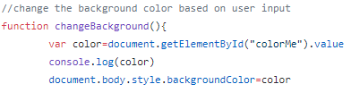

Figure 5- This allows the colour palette to display when the button is click on by the user. This is implemented into the game. The output is a the color that the user selected as the background. This was tested, and it works successfully.

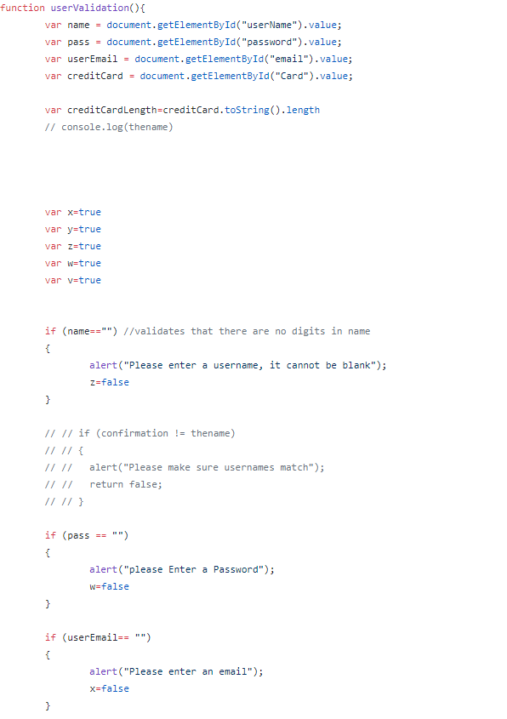

Figure 6- This function allows the validation of the input fields of all name, password, credit card etc. This is by checking that they are not empty and are implemented on the web application. The output should be an alert each time a condition is not satisfied. Each case was tested, and they all function successfully.